The Race to Infinity: A Creative, Theoretical Response to the Call of Action

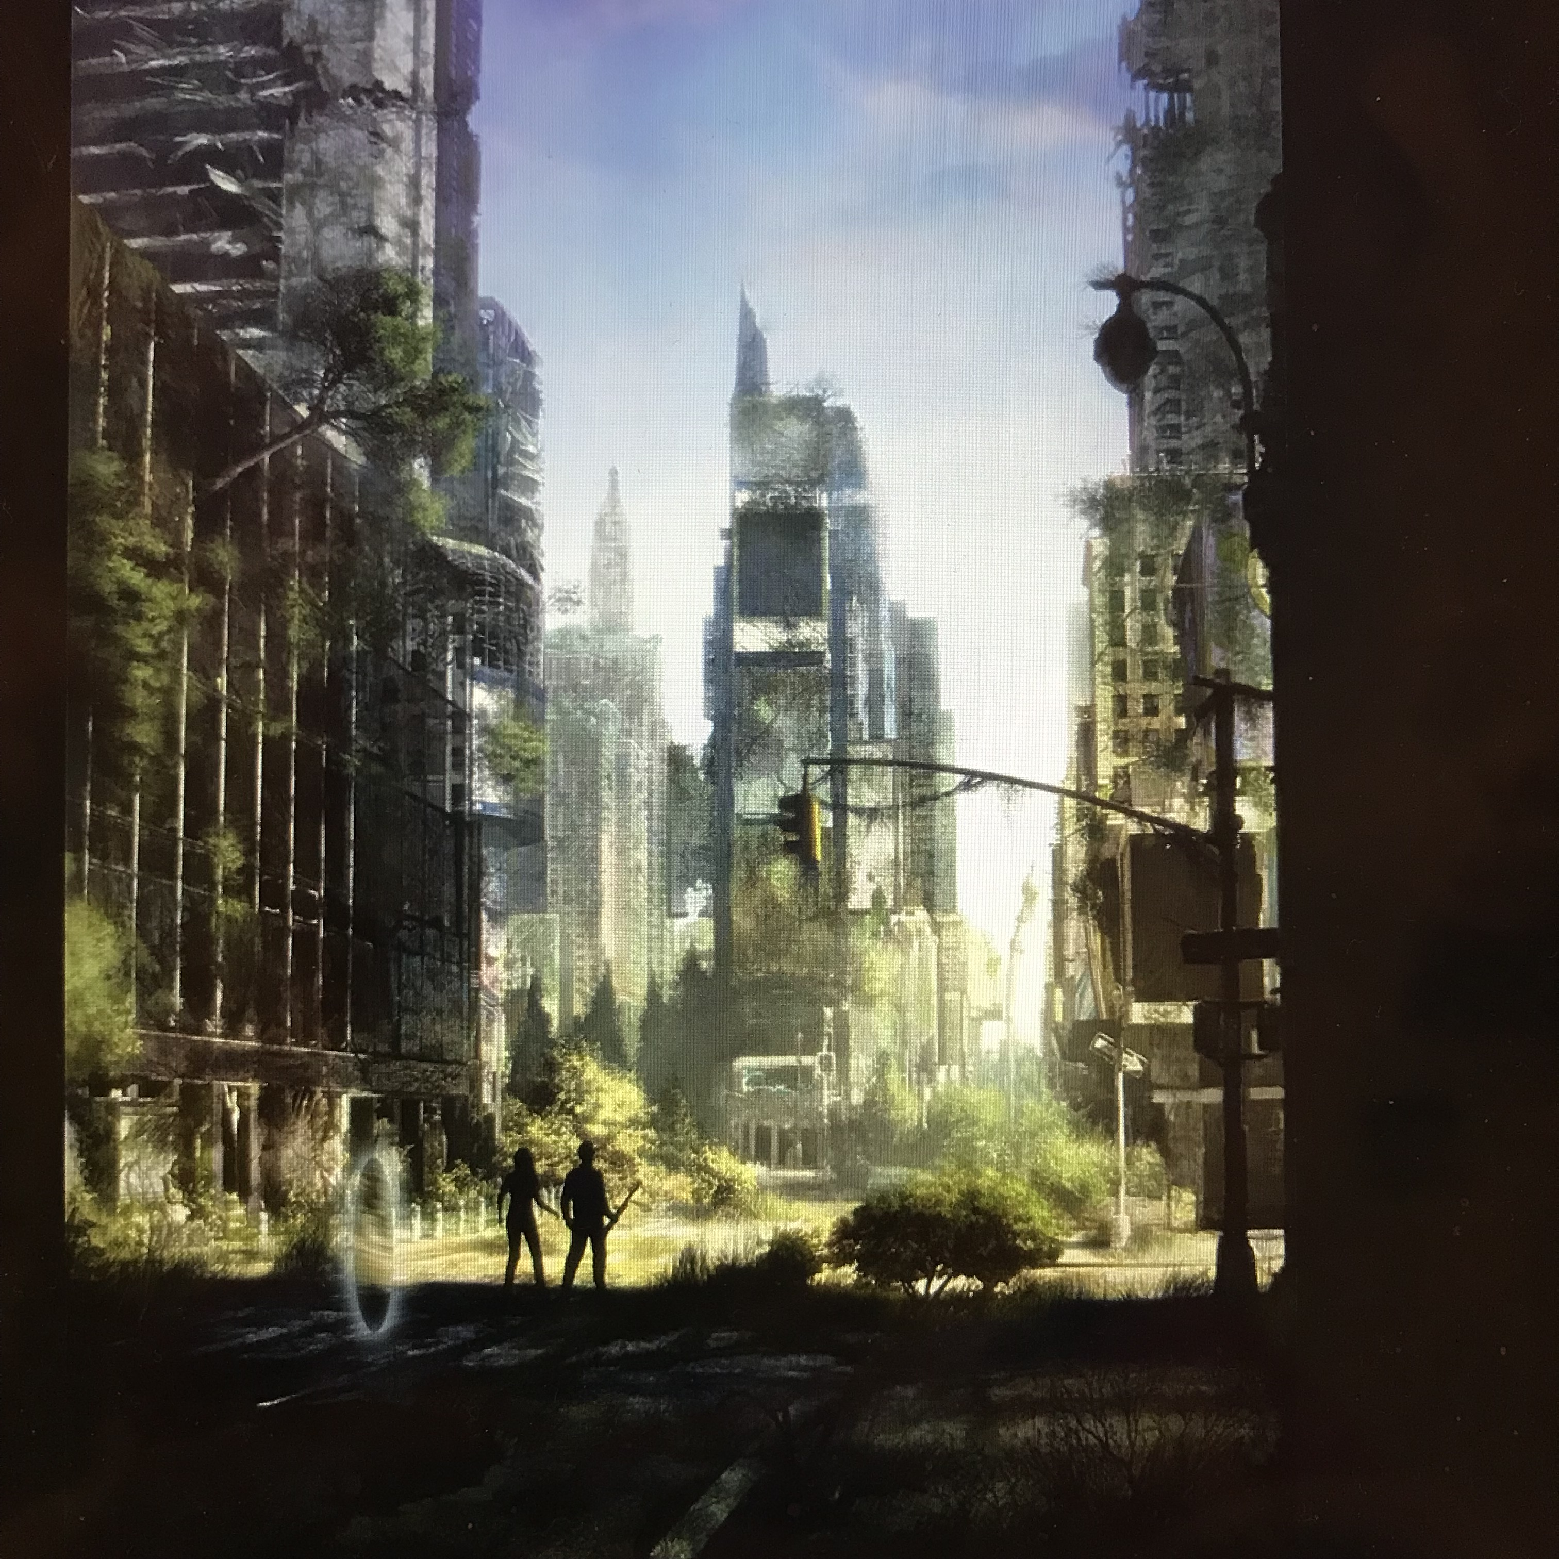
Fig.1: Available at: https://i.pinimg.com/736x/fc/f8/39/fcf839c5850061c9b41f6fc31549f10e--landscape-illustration-mobile-game.jpg [accessed 16 December 2017]

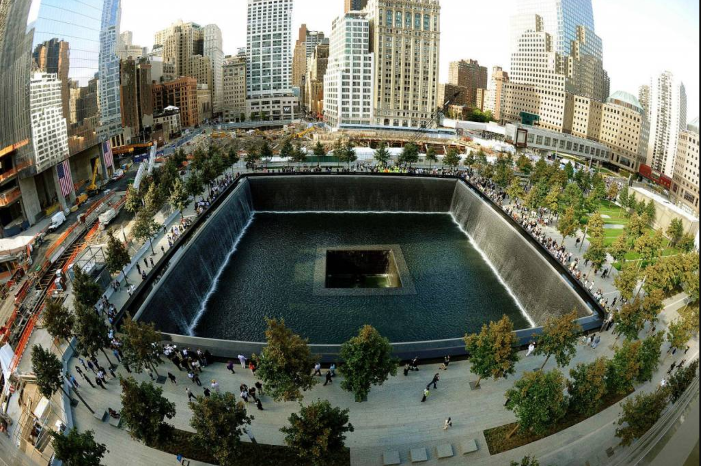
Fig. 2: Available at: http://www.bapscharities.org/usa/national-september-11-memorial-muesum-2/ [accessed 19 December 2017]

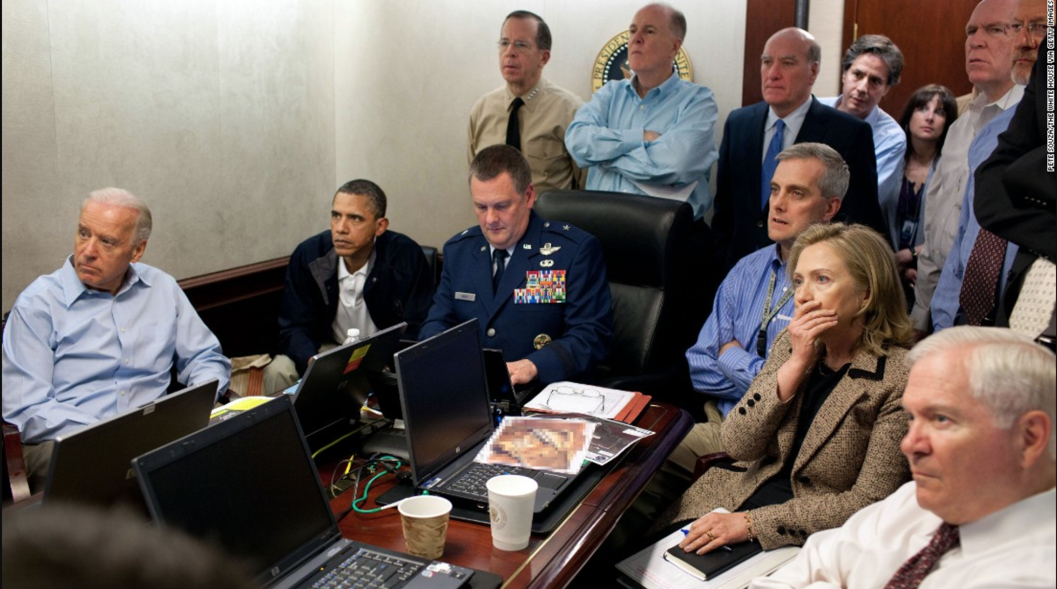
Fig 3: Available at: http://edition.cnn.com/2013/09/09/world/death-of-osama-bin-laden-fast-facts/index.html [accessed 15 December 2017]

The critic Dejan Lukic states that ‘The History of the world could be defined by these two modalities and their interaction: Health and War’; in aligning this with my own subject position, I question Lukic’s use of ‘War’, and her pairing of this with the extensive study of past events. From this intervention, it seemed natural to wonder how this systematic narrative of battle and death which with initial association seems remotely far-off as ‘history’, has mutated in form to occur in my own lifetime within the 21st century. In talking of the contemporary then, the ‘War on terror’ which at times resists the vanquishing of an opponent or claim to victory, proves difficult to be talked about as a tangible, definitive topic within time. From this, I therefore want to ask the fundamental question of, for what purposes does this war happen, so historians can evaluate and document these happenings with confidence, and further re-inscribe the presence of lives lost. Although thoroughly debated, my given line of argument finds most contextual and theoretical resonance with the event of 9/11, a pinnacle occurrence of mass destruction which has blanketed past, present and future in its effect as an act which mightily struck the U.S. political body. To reiterate the question of why in line with observing the movement of the event and its effect as causal representations of one another, my argument for this essay will prevail here. Through analysing and comparing moments and methods of how each force of terror and state action can come into view through the language of theatre and performance, this essay will argue that each force aims to claim both a time and space to overrule pre-emptive living or power, a claim which stands as a form of totality, wholeness or desired ‘once’ moment, be it a utopian vision or temporary holding action occurring in real-time. In understanding this and for the means of this essay however, the spectator who stands outside of the calling action is always deemed docile or isolated, as both forces presume death to be as given excess to the prioritisation of mortality. What I mean by pre-emption is a power space or action operating over a ‘proto-territory tensed with a compelling excess of potential that renders it strictly un-liveable’, this ‘potential’ as Massumi uses here, is what is present over contemporary living space, the omnipresence of striking death. As this unfolds, I will question the supposed opposition of manner spanning across each side, through asking how long this claiming of a singular time or a space can actually be held if read through the eyes of theatrical spectacle and performances, and furthermore, the state we are left in. In the form of primary texts’ then, I will introduce images with the intentions to create a visually immersive, theatrical experience for my reader in order to talk of and comprehend catastrophe. From this therefore, I posit this writing as a creative piece of theory wrapped alongside a standard form which evaluates action primarily.
In developing this then, what does one initially see when observing figure 1, in thinking about the winning over of pre-emptive living through claiming a space and time? I argue that this current territorial feud can take refuge, or find metaphorical association through what this image represents. To be the survivor of a post-disaster, theoretically, attributes a power to those able to see the doomed fate of the earth. This image depicting a fallen civilisation, overridden with greenery and silhouetted against the equipped yet isolated survivors, answers the visual call both to the literary imagination and even future possibility; when weapons have the power to exterminate the globe, dystopia can provide some image of what could be, through measuring scalability. Yet who would survive- those with the resources in pre-prepared hiding spaces? Despite this though, amongst the collapsed depiction of man-made infrastructure and electrical invention, the workings of nature still thrive, almost swallowing the presence of human existence in its over-growth as the figures fade into visual background. There also needs to be, therefore, an equalising agency and power afflicted onto the call of nature, which grows despite the survival and development of societies. Perhaps then, what is most notable and reassuring about what this image represents is exactly this, the inevitable and out-lasting wild growth alongside humanity’s devastation. Like Anna Lowenhawpt’s work on the matsutake mushroom, the first sign of life to grow on the site of Hiroshima was indeed this. She states, the ‘matsutake’s willingness to emerge in blasted landscapes allows us to explore the ruin that has become our collective home’. Her sombre, yet immediate tone is highlighted through the use of ‘become’ in present tense, which reinstates our ‘home’ to be a capitalist ruin that has already become. To expand on this thought, Kellert says, ‘our affinity for nature certainly facilitates material progress’, a statement which implies both a human binding connection for nature’s wonders, yet also the opportunity of bare matter to be made and extracted through this reliance. Combining reading’s such as this certainly brings light to nature’s domination over the human-race in terms of mass life spam, yet also a ‘willingness’, availability and utilisation which subsides alongside this growth. It allows a sense of hopefulness to reside in the survival tale of the cockroach, and can help form this idea of re-birth or origin. It is an image which represents the ultimate winning or searching of land, to which the humanist can master and practically build from the bottom-up in navigating ‘past the danger and accomplishing the transformation of a new Eden’. Such plentiful associations which this image embodies, although imaginary, perform to the eventual break-through to which the rules of this game preside over the mobility of place, and are informed by the idea and hopeful prospect of self-containment, a ‘once’ moment of claiming both time and space which lasted as post-war territory. Not only this, the image similarly represents this scenario alongside a naturally emerging motif of ‘getting back to nature’, whose associations for the means of this discussion can stand as a theory against this melodramatic set-up, and provide a human explanation as to how this terror feud could be settled. Finally, however, the image is also entirely fiction and perhaps quite equally serves in its form, as the mere representation of desired power, a hinting that our home is already doomed as a ‘ruin’, fixed within a flux of inability in holding as a ‘whole’ to which the spectator is never safe.
Keeping this in mind throughout, I would like to introduce my choosing of what images best represent 9/11 and the U.S state action becoming what they are as theatrical and performative motions in action. Standing from an ethnographic standpoint then, figure two visually condenses the remnants of the immediate event, the literal and metaphysical footprint of the imploding towers, as well as the now architectural memorial which stands as part of the city scape. It is a structure which confronts both continuous life and previous death. In choosing this image as representation of 9/11, I questioned from this, at what point does it become involved within the politics of theatre? The image equally manifests both the act conflicted by the terroist group (the event) and the nature of this passing event which prevails (the effect). Through this, we can detect the unfolding aim of the perpetrator in claiming a ‘once’ which stands in opposition to the spectator, being those who did commit the act. In using theatre as a medium, I argue that the event can be considered a theatrical act within itself, and in form of the pitted area which stands as a visual characterisation of ‘Plato’s Cave’. However horrific, a scene was indeed created, one that ‘plays to others’ being the ‘spectators’. The protagonist’s too, those commanding the act, are ‘always above the spectators’ in knowledge and action, as theatre can always be there when one least expects it.
Despite this though, by its very nature, the theatrical event simply occurs and passes. Jaspir Puar’s phrase ‘event-ness’ perfectly captures this movement, to which she goes on further to stress in using the critic Gole, that 9/11 is ‘tethered between its status as a history-making moment and a history-vanishing moment’. Through her indecisive tone, she structurally attempts to define it as a revolutionary juncture which came with subsequent change, yet also a moment which flattens out the history before it. In-between this though, the event still stands and becomes what it is in being simply ‘history’, which is eventually fleeting, or far-off from its point of time origin. In trying to assimilate the unthinkable within language as Puar does, this genre of catastrophe can become something which is retrospectively moulded into theory. As the image depicts then, the event has indeed taken place and is thus localisable, yet can only be appropriated in memory with the ever-changing possibility of a random spectatorial-audience. It is both here, the event marking the place/location, and always elsewhere, the product of this as a method of constructed memory through media. From this mechanism, it is best therefore to characterise the image as a spectacle within the reproduction of ‘event-ness’, which further isolates the spectator from the event as I will go onto explain.
In feeding into my line of argument, it seems clear that the act indeed claimed a space and time temporally, demonstrated from being broadcasted in real-time. It is an act which could not be repeated, a ‘once’ moment through which the centre of globalisation was severely punctured. In attempt to exceed the limits of theatrical limitation, the fourth wall or the theatre’s safety-curtain, a horror-like seizing of reality takes place. Through this, the call to pre-emptively live would only intensify, an un-forgiving warning that the centre was no longer safe from its periphery. Yet, it is this seizing of reality which I want to call into question here, in asking, how long does/can the theatrical act last in the form of claiming a space and time, does it constitute more of a beginning or end? It, as singular theatrical event will always surpass, and in which case can be utilised or reproduced to appear or be remembered in a certain manner through the progression of time, creating a spectacle or image which is very close in place, yet irreducibly remote and far-off from that ‘once’. In reinstating and providing evidence for this, I will now talk of using images as form for a means of representation.
The staging of spectacle we now see, encapsulates an ongoing conversation of how to memorialise or honour the dead. The image which I have selected stands as a completed snapshot which echoes Pia Lindman’s 2002 photographic video, a film depicting the viewing platform which hung above the disaster site before this build. In presenting a layered, palimpsestic loop which recorded the dense inter-weaving of people hovering over the cavernous chasm of Ground Zero as a kind of time-lapse, it simultaneously, as May Joseph uses Michael Taussig to stress, presents an architectural embodiment of the collective gesture of mourning, which ‘records the shift of Ground Zero from a space made ceremonial by the ravages of death to a cult destination for disaster tourists’. It is the writer’s use of shift which strikes me, in marking the developmental motion of a lively city-space through the surplus of image and recordings in what came after the event. The material mass of bodies is overridden by a sublime reaction of fear and intrigue, thus blurring the boundaries between the real and the fictional. The event floats in-between and through its own reproduction, as a catastrophe which is both spatial and temporal.
In response to this however, this reproduction in memorial-form does include the elements of nature- water, stone, perennial plants and bronze. From this very inclusion to document catastrophe by allowing falling water to cascade down to the pits for example, which over-rules the sounds of the surrounding hustle, suggests an implied integrity to the thought of using nature’s materials when civilisation became inverted. In reaching down towards the core of the earth, the purpose of remembrance inter-twining with nature’s treasures could help perpetrate the message that we have survived and have grown as nature does, a visual reminder of overcoming post-apocalyptic ruin. Yet, what wins in strength of visibility here, the message of the survivor or the previous death of the helpless spectator? This discrepancy could be characterised here by the effort to construct an ‘imaginary idea of wholeness’, an identification that insinuates ‘an image of unity while occupying two places at once: the desired place of wholeness and the feared place of discontinuity’, a terror which haunts this very site. It may become a feared place of spatial discontinuity in being a landmark where spectators can pay their respects, or simply lean against whilst on their lunch break, far-off from the event and memorial as a ‘whole’. Now, the possibility to valorise sight can come into play via this spectacle and through media, helping to secure a position from a distance that permits one to view the object in its entirety while remaining safe from it and the event, just as the photographic image does from a birds-eye view. Through this act of gaining a temporary theatre and its inevitable flow of effect, a singularity which taunts the Western dream of self-identity, those alive like the spectators in the image are safe, yet isolated from the unattainable deaths within this multiplying layering of spectacle, image and time.
At this point, I think it is fair to say that as argument has developed through representation alongside this image of the site, that there is also a possibility of ‘ongoing theatrical happenings’, effects which occur following the event. These can either ‘be contained within the place where they unfold’, or ‘entirely separate from it’, to which, ‘out of the dislocations of its repetitions emerges nothing more or less than the singularity of the theatrical event’, and its irreducible opaque effect through subsequent time. I question from this, in light of ‘theatrical happenings’, how does power attempt to re-build momentum in re-claiming this U.S territory which was suddenly struck through theatre? As the image manifested, when the post-event becomes saturated by political media, these ‘theatrical happenings’ find resonance through a set of responses which can only be reactive. My use of ‘reaction’ here consists of a performative quality, marking figure two as a visible hole, yet also as an underlining of active naming to ‘(Al Qaeda), to give face to (Osama bin Laden) and above all [location] in Afghanistan, Tora Bora, Iraq, Sudan, Somalia etc)’. In introducing figure three, with regard to the essence of determined stare and gesture, the U.S state claim through doing. The viewer is encouraged to follow and look ahead, a visual schematic encouragement of the fear of death to project itself onto an image of the now other, and as the angle and capture of the image embodies, the spectator has no choice other than to ‘identify with the ostensibly innumerable perspective of the camera’. Yet again, the spectator is docile, frightened or put to death for the greater good. To secure a space and time, or a pre-emptive win over the opposing force, a utopian future is brought closer, assuring the triumph of government over the earth itself.
Figure three depicts the live assassination of Osama bin Laden. It is a photograph which captures a momentary transition, only ever being able to represent one singular space-time cut of a sudden kill. Through the very act of looking at this photograph, the spectator too becomes an active accessory to the killing, reuniting a force of collectivity to which death is used as a progressive tool in the fight towards re-claiming space by exterminating the perpetrator through this ‘once’ moment. In expanding on my use of ‘performance’ here, it can be used within this context as an adjective in a non-discursive, expressive sense in analysing the performative energy of the actual process and somatic and linguistic impact of a particular performance. The photograph, becomes the absolute testament to the event, and through its production and distribution, a still shot is cemented in marking the process of cinematically doing as Clinton gasps in response to the justice done. The successful distribution of the photograph relies on its shock-value in only being able to represent one singular space-time preserve. Through such documentation, this event again becomes a distant venture as the body of the enemy becomes uncannily close. It demonstrates a visual depiction of active military intervention, a reactionary claiming of space/time where foreign and domestic policy meet and perhaps most vibrantly, visual reassurance that for the future to come now, the present moment must be lived or assembled pre-emptively. In grasping a moment from afar through bio-order, a vision of this utopian re-claimed homeland is settled from state action, if not only for a very brief photographic experience.
Yet, through what means of performance is this future to be acted upon, if it is to come now? The photograph, from its practical distribution and content matter, becomes what it is through demonstrating an action being put into place, to which only a few heroic individuals can observe and claim the earth from terror, or have the capacity to prepare us for what is to come through the necessity of military intervention, reflecting back to the isolated, yet equipped survivors as seen in figure one. Before my very eyes, this reactionary image demonstrates the actions of ‘theatrical happenings’ which perform for certain means from a visual standpoint, or more importantly, through a created dichotomy between ‘us’ and ‘them’. Although the Iraq Wars stand as debateable subjects as being a fundamental product of 9/11, they do indeed demonstrate the hostility between the U.S and the Middle East which has arisen from Bush’s declaration of the ‘war on terror’. I therefore question, as part of the government’s reactive performances, the language which is applicable to such a war, as Eric Pahon states, ‘the unfortunate death of civilians is a fact of war that weighs heavy on our hearts’. Within the lexical choice of ‘fact’ intertwining with ‘death’ and ‘war’, there is little or no room to breathe or to alternatively question the statement when a combination is aligned with ‘fact’. It suggests that the actions of the Iraq War were indeed known and somewhat expected, yet always unintentional. Massumi’s essay expands on this as he equates this nature of thought with nature itself. Just like how it grows without necessary human causation, as well as by its singular-generic ascription, it can be easily associated with the force of the imminent reality of accident, to which Massumi’s use of ‘Obama’s team’s accidental assimilation of “national security” to “natural security” could not seem more relevant. Through the ‘backing-up’ of nature’s call, the war on terror through its ‘doing’ performative qualities can define almost as a necessary ritual, its justification necessary as the killing of Osama became a tangible bounded event that involved the presentation of rehearsed articulation. The excessive use of sovereignty demonstrates quite literally, how the success of terror-politics becomes embodied or manifested within the body of a fighting soldier or the body of a military killing, suggesting that the foreboding presence of death lingers through an almost human form. This uncanny personification, not only suggests that death and the right to kill is excessive to the priority of war and civilian life, yet proves imperative to sustain this performance in guaranteeing the position of the state as an exception, and for valorising its subsequent killing of those stateless people who lie outside of the room in the image.
Yet again however, in coming back to this central question, how long can this ‘win’ last or remain effectively claimed within a space and through the succession of time, to secure a stop to pre-emptive living? It is a question which proves relevant for each end of the spectrum. In taking the theoretical stance by exploring these modalities through theatre and performance, theories which eat away space and time before we can attempt to write about them, proves to be a perspective which can tellingly relate to a rather realistic image, or perhaps unveil the very nature of this war on terror, or assist to uncover how to deal with terror itself. It seems that these aimed actions can indeed only ever gain temporary momentum, a brief restoration to the body politic or be entirely short-lived before the space is once again seized, as we need not only look to the events of the past year of 2017. Through the course of this essay, I suggest that nobody is ‘winning’ here for prolonged time, yet death and isolation still occur for those not committing acts. Perhaps, what can best summarise this contemporary moment in reflection of the events, lies in the nature of terror itself. Terror, seems to come from a future colliding with the present moment, as ever-anticipated risk made real by bodily detonation. As has been evident throughout with examples condoning the ‘war on terror’, the present moment cannot be contained or held, as the future of imminent risk deems unnervingly close, to which death could strike at any point. Yet, in using the phrase bodily detonation I argue, brings home a certain immediacy to the sparing of human life for such causes. In coming back to the introduction, perhaps an attempt to talk of terror through a tangible or simplistic method in order to resume conclusion, can find resonance within something which is naturally human. Again, I come back to Dejan Lukic, who outlines this war on territory, and to which certain examples I have used further highlight the meaningfulness of the natural world, and its appropriation to this context. The author interestingly sets up a central mechanism of ‘politics-territory-animal’, a mechanism which works through the idea of a hostage space, a space which I argue defines the terrain of this war through trapping, capturing and most prominently, being on the lookout. She states that:

conflict lies not in the resolution of the crisis but in the new way of treatment of animality- including and especially one’s own animality- as a threshold dependency on territory: physical (the gravitational pull of the earth), ontological (either being thrown into this world or else being strangled and looking for an exit, as the sovereign of the outside), and esoteric (belonging to the divine). Only then will one be able to resist constantly being on the lookout- the insecurity of an outcast, as well as the false comforts of political subjectivities.

The passage stands as a plea for political discourse to deconstruct the very materiality of the insistent claim for territory, as this essay has outlined in identifying the over-arching desire to withhold a ‘once’ moment in acting within the politics of theatre and performance. To deconstruct this, one must recognise the primary mechanism which outlines this race through space and time together with the interaction of the inside and outside, to further recognise one’s ‘own animality’ which plays out over this interaction. One must rise above this through administering human dignity. Perhaps then, in taking refuge from working from the ‘bottom-up’ as I introduced in figure one, from associating with the ‘natural world’ and its connotations of the basic or primal, can in fact act as a neutraliser in understanding why and what of the human condition and its traits within this War, instead of aiming to conquer time and space in awe of a far-off dystopian ruin. One must listen to the call of nature to help restore the spectator’s autonomous position and settle land which is wretched with nerves. One must use this for understanding and solvability or just for plain reassurance, before these forces which intervene through one another quite literally self-implode through their aims over the plain of civilian livelihood.

Bibliography:
- Buncombe, Andrew, ‘America has no idea how many innocent people it’s killing in the Middle East’, Independent, 20 November 2017 < http://www.independent.co.uk/voices/us-isis-air-strikes-civilian-deaths-syria-iraq-america-no-idea-how-many-dead-the-uncounted-a8066266.html> [accessed 24 Dec 2017]

- Jacobs, Robert, ‘Filling the Hole in the Nuclear Future’, in Filling the Hole in the Nuclear Future: Art and Popular Culture Respond to the Bomb, ed. by Robert Jacobs (Maryland: Lexington Books, 2010), pp. 1-9

- Joseph, May, ‘Fascia and the Grimace of Catastrophe’, in Beyond Biopolitics, ed. by Patricia Ticieneto Clough and Craig Willse, pp. 332-351

- Kellert, Stephen, Kinship to Mastery: Biophilia In Human Evolution and Development (Washington D.C: Island Press, 1997)

- Lowenhampt, Tsing Anna, The Mushroom at the End of the World: On the Possibility of Life in Capitalist Ruins (New Jersey: Princeton University Press, 2015

- Lukic, Dejan, Hostage Spaces of the Contemporary Islamicate World: Phantom Territoriality (London: Bloomsbury, 2013)

- Massumi, Brian, ‘National Enterprise Emergency’ in Beyond Biopolitics: Essays on the Governance of Life and Death, ed. by Patricia Ticieneto Clough and Craig Willse (Durham: Duke University Press, 2011), pp. 19-45

- Puar, Jasbir, Terroist Assemblages: homo-nationalism in queer times (United States: Duke University Press, 2007)

- Weber, Samuel, Theatricality as Medium (New York: Fordham University Press, 2004)

Dejan Lukic, Hostage Spaces of the Contemporary Islamicate World: Phantom Territoriality (London: Bloomsbury, 2013), p. 20.
Brian Massumi, ‘National Enterprise Emergency’ in Beyond Biopolitics: Essays on the Governance of Life and Death, ed. by Patricia Ticieneto Clough and Craig Willse (Durham: Duke University Press, 2011), pp. 19-45 (p. 30).
Anna Lowenhaupt Tsing, The Mushroom at the End of the World: On the Possibility of Life in Capitalist Ruins (New Jersey: Princeton University Press, 2015), p. 3.
Stephen, R. Kellert, Kinship to Mastery: Biophilia In Human Evolution and Development (Washington D.C: Island Press, 1997), p. 7.
Robert Jacobs, ‘Filling the Hole in the Nuclear Future’, in Filling the Hole in the Nuclear Future: Art and Popular Culture Respond to the Bomb, ed. by Robert Jacobs (Maryland: Lexington Books, 2010), pp. 1-9 (p. 2).
Samuel Weber, Theatricality as Medium (New York: Fordham University Press, 2004), p. 4.
Jaspir Puar, Terroist Assemblages: homo-nationalism in queer times (United States: Duke University Press, 2007), p. xviii.
May Joseph, ‘Fascia and the Grimace of Catastrophe’, in Beyond Biopolitics ed. by Patricia Ticieneto Clough and Craig Willse, pp. 332-351 (p. 334).
Weber, p. 332.
Weber, p. 7.
Weber, p. 333.
Weber, p. 335.
Andrew Buncombe, ‘America has no idea how many innocent people it’s killing in the Middle East’, Independent, 20 November 2017 < http://www.independent.co.uk/voices/us-isis-air-strikes-civilian-deaths-syria-iraq-america-no-idea-how-many-dead-the-uncounted-a8066266.html> [accessed 24 Dec 2017]
Massumi, p. 27.
Lukic, p. 16.

